**Tuesday, March 21st**

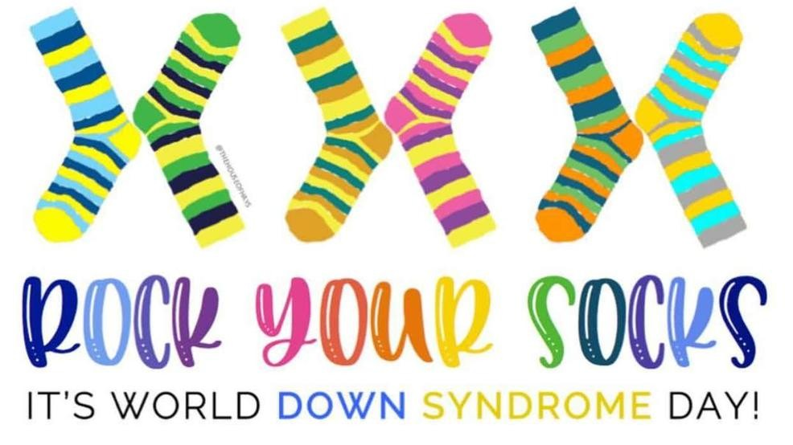

Every year, on 3/21, people all around the world come together to celebrate World Down Syndrome Day by wearing brightly colored, mismatched socks.  **March 21 is symbolic because people with Down syndrome have 3 copies of their 21st chromosome.** Socks were chosen because the karyotype of DS chromosomes looks like mismatched socks!  
  
Please join us in wearing mismatched socks on Tuesday to celebrate World Down Syndrome Day.  
  
Together we can advocate for the rights, inclusion, and well-being of people with Down Syndrome in our community.  